# Security Vulnerability in Red Roosters Online Ordering System * CVSS 5.3

By [Jack Weller](https://github.com/jackwellerreal)

Please note that this exploit works as of making this document (15/12/2024)

On December 10, 2024, I discovered a vulnerability in Red Rooster's online ordering system. This issue allows customers to place orders without payment, whether for pickup or delivery. The vulnerability arises from the ability to modify the "cart" variable in session storage to set the total price to $0. This manipulation causes the website to mistakenly recognize the transaction as a special offer or voucher, bypassing the payment page and allowing the order to be processed without requiring payment details.

This is a clear example of client-side validation being relied upon without sufficient server-side checks, leaving the system vulnerable to exploitation. If this issue is not addressed, there is a risk that others may discover and abuse the exploit, leading to significant financial losses for franchise owners and the company as a whole.

## **Steps to Reproduce**:

1. Open the Red Rooster website and add items to the cart

1. Open the developer tools built into the web browser and navigate to “Application” for Chrome and Edge, or “Storage” for Firefox

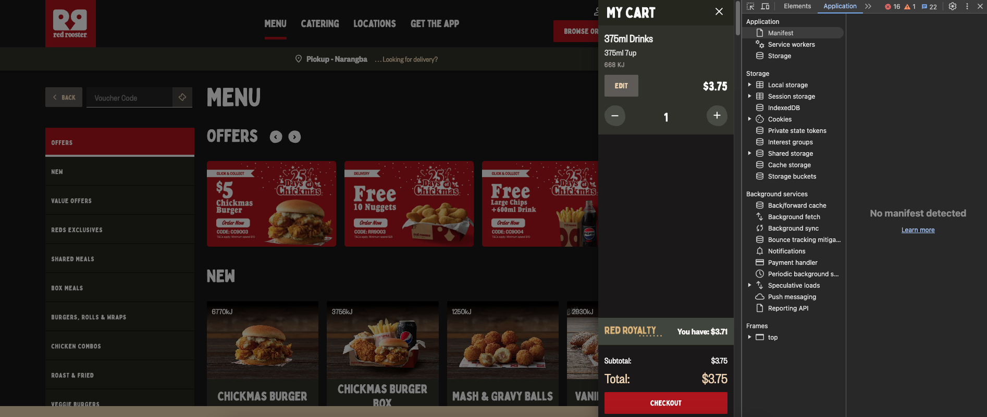

1. Click on “Session Storage” and locate the URL for the Red Rooster website

1. Copy the cart variable

1. Go to a website like [jsonformatter.org](https://jsonformatter.org/) and beautify it to make the JSON readable

1. Scroll to the bottom of the text and change the total value to 0 or whatever price you want to pay

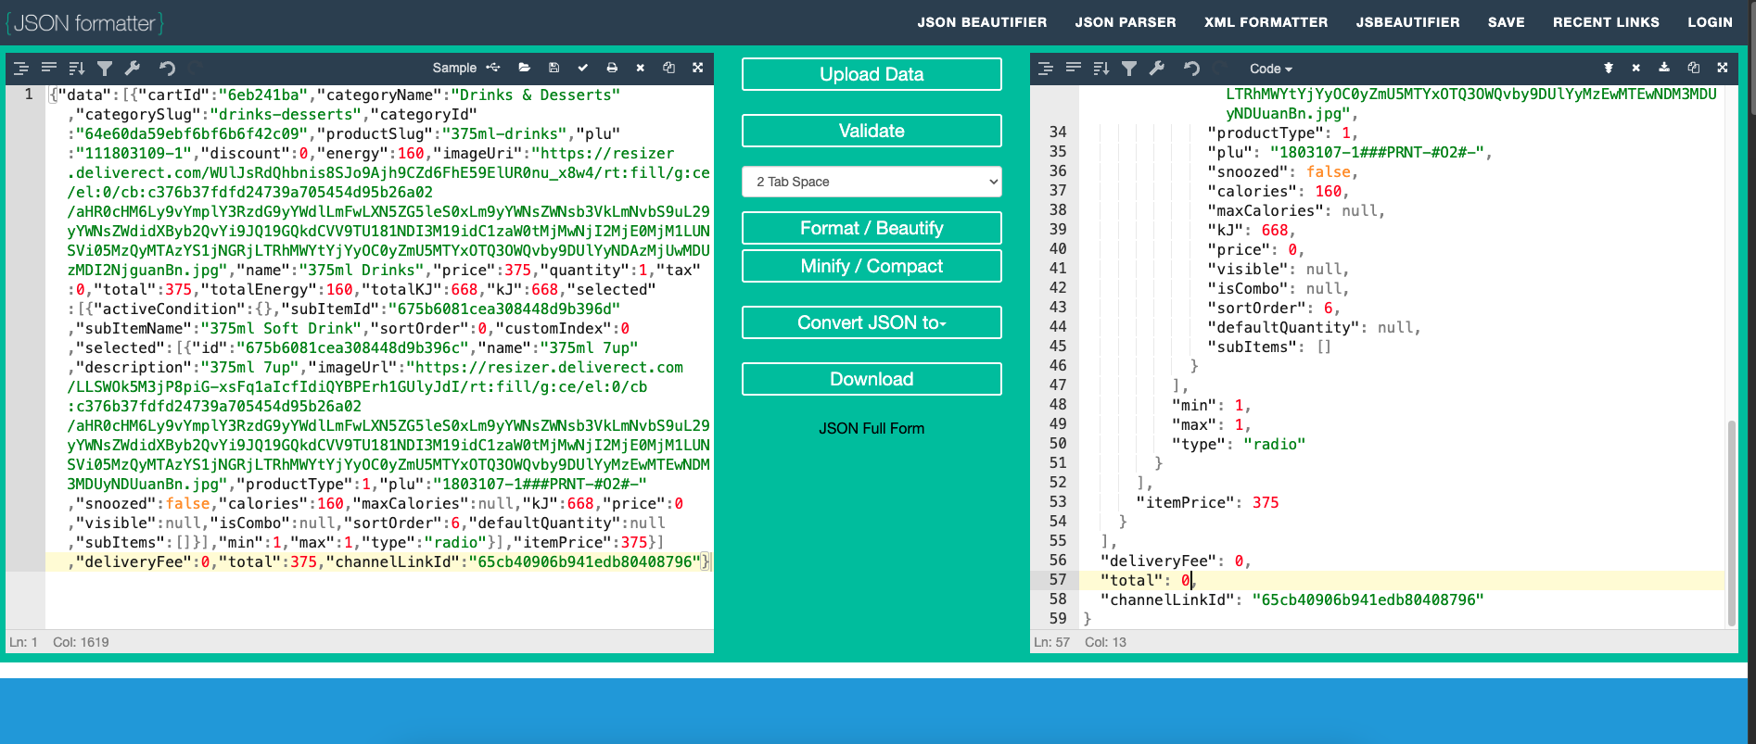

1. Click minify and copy the compacted text, then head over to the red rooster website and replace the cart variable with the new code.

1. Refresh the page and go to my cart, if you did everything correctly it should say “Total: $0.00”

1. Click on “CHECKOUT” and “CONTINUE TO PAYMENT”, then you can click “GET FREE FOOD” to submit the order

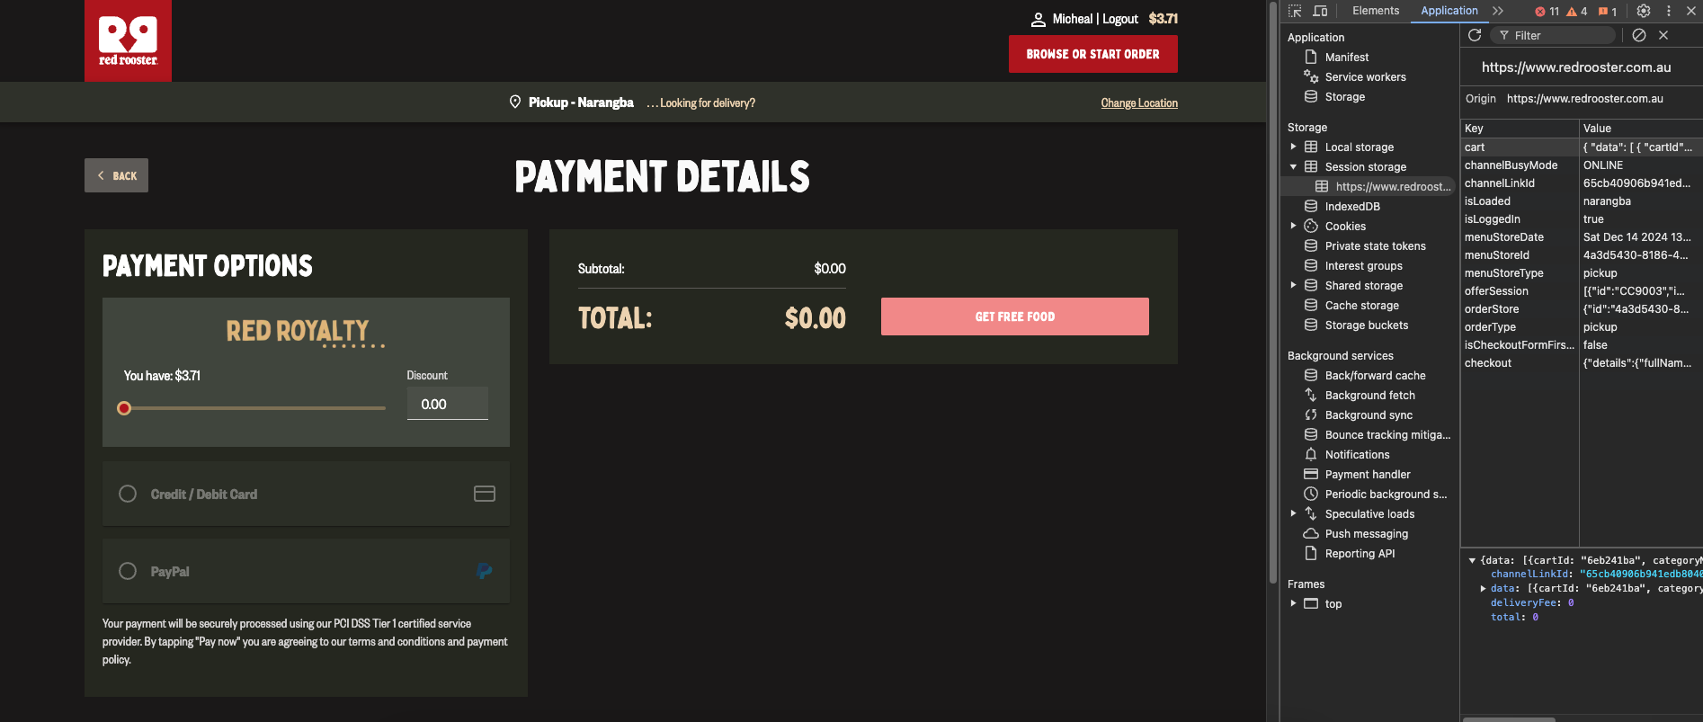

In this example I did not purchase the item, it was for demonstration purposes only.

This exploit only works with in store pickup. Delivery doesn’t work because it is managed by Door Dash.

## **Technical Details**:

**Vulnerability Type**: Client-side validation flaw

**Affected Component**: Online ordering system, specifically the cart management and payment page

**Exploit Mechanism**:  
The vulnerability arises because the cart’s total price is stored in the browser’s session storage, which can be easily modified using developer tools. The server does not validate the manipulated price, allowing an attacker to change the cart’s total to $0. Once this is done, the website incorrectly assumes the item being purchased is free, skipping the payment page and processing the order without asking for payment details.

**Detailed Example of the Exploit:**

1. The cart object in session storage contains product data, quantities, prices, and totals.
2. The attacker can modify the "total" value in session storage to $0 using developer tools.

**Example of cart data before manipulation**:  
{

"data": [

{

"cartId": "6eb241ba",

"categoryName": "Drinks & Desserts",

"productSlug": "375ml-drinks",

"name": "375ml Drinks",

"price": 375,

"quantity": 1,

"total": 375,

"selected": [

{

"subItemName": "375ml Soft Drink",

"selected": [

{

"name": "375ml 7up",

"price": 0

}

]

}

],

"itemPrice": 375

}

],

"total": 375,

"deliveryFee": 0

}

**Example of cart data after manipulation**:

{

"data": [

{

"cartId": "6eb241ba",

"categoryName": "Drinks & Desserts",

"productSlug": "375ml-drinks",

"name": "375ml Drinks",

"price": 375,

"quantity": 1,

"total": 375,

"selected": [

{

"subItemName": "375ml Soft Drink",

"selected": [

{

"name": "375ml 7up",

"price": 375

}

]

}

],

"itemPrice": 375

}

],

"total": 0, // Manipulated total

"deliveryFee": 0

}

Please note that the JSON strings above will not work when pasted due to having certain identification codes removed in order to make the code more readable

**Impact**:

If exploited, this allows the attacker to bypass the payment page and submit the order with a total price of $0. This would result in unauthorized free orders, causing financial losses for Red Rooster.

## **Impact Assessment**:

If this vulnerability is exploited, it could allow malicious actors to place orders without paying, leading to significant revenue loss for the company. As Red Rooster is a popular brand with a high volume of orders, the exploitation of this flaw could result in large-scale financial losses, especially if discovered and exploited by others.

In addition, the news of a security vulnerability that allows unauthorized orders could damage the company’s reputation. If customers become aware that the online ordering system is insecure, it could erode trust in the brand and drive potential customers away.

Furthermore, Red Rooster’s loyalty program, Red Royalty, requires customers to provide personal information such as their full name, phone number, email address, birthday, and home address for delivery orders. If something as simple as changing a variable can make an order free, a cybercriminal with more time and money could potentially gain access to this sensitive data. This could lead to identity theft or other malicious activities.

## **Suggested Fixes**:

**Implement Server-Side Validation**:  
Currently, the system relies on client-side validation, which can be manipulated using developer tools. To prevent this, all price-related calculations and validation should be moved to the server side. The server should verify the total amount and ensure that it matches the expected price before allowing the order to be placed.

**Encrypting Session Storage**:  
Instead of storing the cart in plain text, encrypt the cart data so that the client cannot spoof it. This will prevent unauthorized manipulation of the cart total and other sensitive information. The server should decrypt the data for processing and validation, ensuring that any changes to the cart total are securely handled.

**Penetration Testing**:

Regularly conduct penetration testing using third party companies, to identify potential vulnerabilities in the application. Additionally, consider setting up a formal bug bounty program to encourage responsible disclosures and improve the security of your platform.

## **Conclusion:**

The vulnerability discovered in Red Rooster’s online ordering system poses a significant security risk, as it allows malicious actors to bypass payment processes and place unauthorized orders. If left unaddressed, this could lead to substantial financial losses, reputational damage, and potential exploitation of customer data.

By implementing server-side validation, encrypting sensitive data stored on the client-side, and strengthening security measures overall, Red Rooster can mitigate these risks and improve the security of its platform. Prompt action is crucial to prevent the vulnerability from being exploited by others, which could harm the business and its customers.

I urge Red Rooster to address this vulnerability as soon as possible and consider implementing additional security measures, such as regular security testing and the establishment of a bug bounty program, to enhance the long-term protection of the platform.

Thank you for your attention to this matter. I look forward to your response and to working together to resolve this issue.